
Announcement of Lao Luang Provincial Police Station
Re: Intention not to accept gifts or gifts of any kind from the performance of duties
(No Gift Policy)
Lao Luang Provincial Police Station It is committed to developing its operations to be transparent, adhering to the common interest rather than personal interests. There is no conflict of interest, in line with the national reform plan. Prevention and Suppression of Corruption and Misconduct (Revised Version), which aims to ensure that agencies operate with transparency and no benefits.
Therefore, I would like to declare the intention of the Superintendent of the Lao Luang Provincial Police Station and the police officers. All officers will not accept gifts or gifts of any kind from the performance of their duties (No Gift Policy). Organization and Values of Integrity in Operational Conduct The patronage system is not accepted. Avoid actions that may affect the discretion or decision to perform duties that lead to discrimination. Prevent unfair performance of duties and avoid conflicts of interest, as well as build public confidence in performing duties with good governance.

Therefore, it is announced and strictly observed in general.
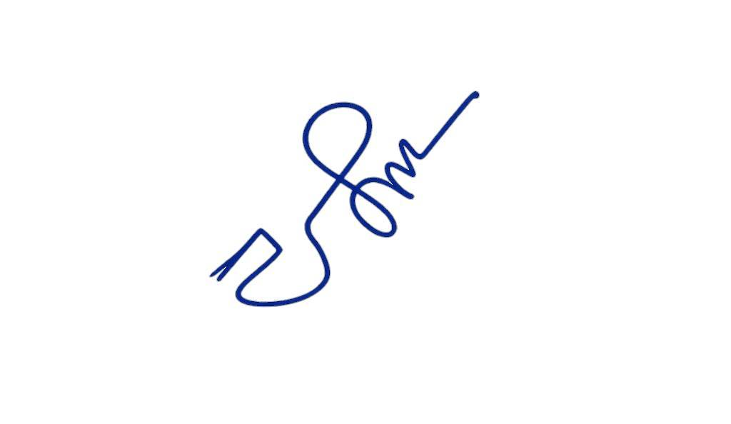
Announced on 31 March 2026

Pol.Col.
( Yanatouch chaipocharachote )
Deputy Commander Acting Superintendent
of Lao Luang Provincial Police Station

