

Announcement of Lao Luang Provincial Police Station
story Anti-Bribery Policy and No Gift Policy for the Fiscal Year 2026
According to the Constitutional Act on Prevention and Suppression of Corruption, B.E. 2561 (2018), Section 128, Paragraph 1, prohibits any government official from receiving property or any other benefit that may be calculated as income from anyone. In addition to property or legitimate benefits under the law. Rules or regulations issued by virtue of the authority under the provisions of the law, except for the receipt of property or any other benefits by the Board of Directors. The NCPO stipulates and the Code of Ethics for Civil Servants. Police B.E. 2564 (2021) Clause 2 (2) Honesty Perform legal duties. The rules and regulations of the National Police Agency with transparency do not express behavior that implies exploitation, illegality, and responsibility for human rights duties. Ready to be audited and held accountable. Have a good conscience, consider society, and 2 (4) think about the common good rather than personal interests. Have a public spirit, cooperation, cooperation, and sacrifice in doing things. Benefit for the common good and create for the benefit of society in conjunction with the National Reform Plan on Prevention and Suppression of Corruption and Misconduct (Revised Edition) Define Major Reform Activities Activity 4 Develop the Thai Bureaucracy to be Transparent and Non-Profit Goal 1 Clause 1.1 All government agencies and units shall declare as agencies where all government officials do not accept gifts and gifts of any kind from the performance of their duties (No Gift Policy).
Therefore, in order to prevent conflicts between personal and public interests, bribery, gifts, gifts, or any other benefits that affect the performance of their duties, the Lao Luang Provincial Police Station Therefore, the Anti-Bribery Policy and No Gift Policy are established as follows:
Announcement of Lao Luang Provincial Police Station on Anti-Bribery Policy and No Gift Policy for Duty for the Fiscal Year B.E. 2566 (2026)
objective
1. To prevent or reduce the opportunity to receive bribes. Conflicts of interest in various forms for police officers under the Lao Luang Provincial Police Station.
2. To encourage police officers. Under the affiliation of the Provincial Police Station, the Luang Police Station has a consciousness of Refuse to accept gifts and gifts of any kind in the performance of their duties.
3. To create a strong and sustainable organizational culture of integrity and transparency in the bureaucracy.
4. To determine the measures. Guidelines and mechanisms to prevent bribery/receipt of bribes or any other benefits.
5. To determine the guidelines for receiving fees, certifications or gifts of executives and police officers under the jurisdiction of the Sophisai Provincial Police Station in accordance with relevant laws and regulations.
6. To support and enhance the implementation of the National Strategy, the Master Plan under the National Strategy and the National Reform Plan on the Prevention and Suppression of Corruption and Misconduct, as well as to be part of the Integrity and Transparency Assessment (ITA) guidelines.
Scope of application
It applies to all police officers under the Royal Provincial Police Station.
meaning
"Bribe" means property or other benefits given to a person so that he or she acts or refrains from doing any act in his or her position, whether it is lawful or unlawful as required by the person paying the bribe.
"Gifts, gifts, or any other benefits that affect the performance of duties."
means money, property, services or any other benefits of value and given, including tips, received by government officials in addition to salaries, income, government benefits in normal circumstances and affecting decision-making. approval (3) at the time of receipt or in the future.
"Property" means intangible property and objects that may have value and may be held, such as money, houses, cars, stocks, etc.
"Receiving property or any other benefit by virtue" It means receiving property or any other benefit from relatives or from individuals who give to each other on various occasions, usually according to customs or culture, or giving to each other according to the etiquette practiced in society.
"Relative" means the father, the successor. Siblings with parents or with the same father or mother. Uncles, aunts, uncles, spouses. Parent or descendant of a spouse, adopted child or adoptee
"Any other benefits" It means something of value, such as price reduction, entertainment, receiving, services, training, or anything else of the same kind.
"Duty Performance" It means that it is an act or performance of duties of a government official. In a position that is appointed or assigned to perform any of the duties or to act on behalf of the government. One of the duties is both general and specific as a police officer prescribed by law. or act in accordance with the powers and duties specified by law to have the authority and duties of the police.
"Superior" means a person who has the authority and duty to direct, supervise, monitor and inspect police officers under his or her jurisdiction.
"Subordinates" means all police officers under the Lao Luang Provincial Police Station. In addition to the superiors.
Guidelines for Preventing Bribery
One. Police officers under the Lao Luang Provincial Police Station are prohibited from All officers are involved in giving or receiving bribes in any form, either directly or indirectly.
Two. Police officers under the Lao Luang Provincial Police Station are prohibited from All officers. Demand or receive Bribery for personal gain or the benefit of another person.
3. To comply with the anti-corruption policy without being involved in the Corruption, whether directly or indirectly.
4. The performance of duties must comply with the regulations. Police discipline and related laws are strictly enforced.
5. Do not commit any act that falls under the category of giving or accepting bribes.
6. Supervise the disbursement of expenses of affiliated agencies in accordance with the law. Strictly related regulations.
7. Receipt of donations or grants, whether in kind or property, for any activity or project must comply with the regulations. Regulations and announcements are strictly and there is a receipt or proof of receipt. The money is reported every time.
8. Receipt of property or any other benefits by Dhammacharya to police officers under the station. All Royal Provincial Police officers must comply with the announcement. National Corruption Prevention and Suppression Commission Criteria for Receiving Property or Any Other Benefits by Ethics of Officers, B.E. 2543 (2000) Strictly
Penalties/Violations of the Code of Conduct
One. Failure to comply with this policy may result in disciplinary action or criminal prosecution or other relevant laws, including direct supervisors who ignore the wrongdoing or acknowledge that the act has been committed. Wrong but not handled correctly. which has a disciplinary penalty up to dismissal from the government.
Two. Failure to be aware of this Policy Notice and/or applicable laws cannot be used as an excuse for non-compliance.
3. The supervisor according to the Police Department's Order No. 1212/2537 dated October 9, 1994 has the authority. The duty to supervise the subordinates under the administration to strictly adhere to and comply with this policy.

Monitoring measures
1. Superintendent of Lao Luang Provincial Police Station Declare the intention to administer the agency honestly, honestly, transparently, and in accordance with the principles of good governance by disseminating public information to police officers under their jurisdiction and external stakeholders.
2. The Commanders shall have the authority and duty to supervise, monitor and inspect the police officers under their command according to the Police Department's Order No. 1212/2537 dated October 9, 1994. In the affiliation, they shall behave in accordance with this Announcement. In case of any violation of this Notice, report to the Station Superintendent. Lao Luang Provincial Police Know as soon as possible.
3. The Lao Luang Provincial Police Station will arrange an audit and evaluation of the results of the implementation of the guidelines. This is done annually and the Compliance Guidelines are reviewed and updated at least once a year or in response to significant changes in factors.
4. The Directorate of the Lao Luang Provincial Police Station Prepare statistics on receiving gifts or Any other benefits along with problems, obstacles, solutions, and then report to the Superintendent of Lao Luang Provincial Police Station. Know every quarter
Complaint / Whistleblowing Channels
1. Corruption and Misconduct Whistleblowing Center, Lao Luang Provincial Police Station
2. By phone at 042-416-045
3. On Web page laoluang.buengkan.police.go.th
4. On the Facebook page of Lao Luang Provincial Police Station.
Whistleblower Protection Measures Confidentiality and measures to protect petitioners and witnesses
One. Consideration of complaints shall be classified as confidential and protected persons in accordance with the regulations on The informant and the petitioner may suffer, for example, the complaint against the civil servant shall be considered as an official secret. In case the circumstances are obvious, as well as pointing out the exact witnesses only. Whistleblowing influencers must conceal the name and address of the petitioner. If the name and address of the petitioner are not concealed, the relevant authorities must be notified and provided protection to the petitioner as follows: "The supervisor shall exercise discretion and give reasonable instructions to protect the petitioner, witnesses and persons providing information in the investigation and investigation from suffering harm or injustice that may arise from the complaint, witnessing or providing information." In case the name of the accused is identified, both the petitioner and the respondent must be protected because the matter has not yet gone through the investigation process. facts and may be bullying, accusations, to suffer and suffer, and the case of the complainant stated. In the petition, please conceal or do not wish to disclose the name of the complainant. The agency must not disclose the name of the petitioner to the agency or the respondent because the petitioner may suffer according to the cause of the complaint.
Two. When there is a complaint The petitioner and the witness will not be subjected to any action that affects their work or livelihood. If any action is necessary, such as separating the workplace to prevent the complainant from taking action. witnesses and accused people meet each other, etc. The consent of the petitioner and witnesses is required.
Three. Victim's Request For example, the request for a change of workplace or the method of preventing or resolving the problem should be considered by the responsible person or agency as appropriate.
4. Protect the complainant from being bullied.
Measures to protect the accused
One. During the hearing of the complaint, the accused was not considered guilty. They must be fair and treated like other people.
2. Give the accused the opportunity to fully clarify the allegations, including the right to present documents/evidence.

However, From now on.
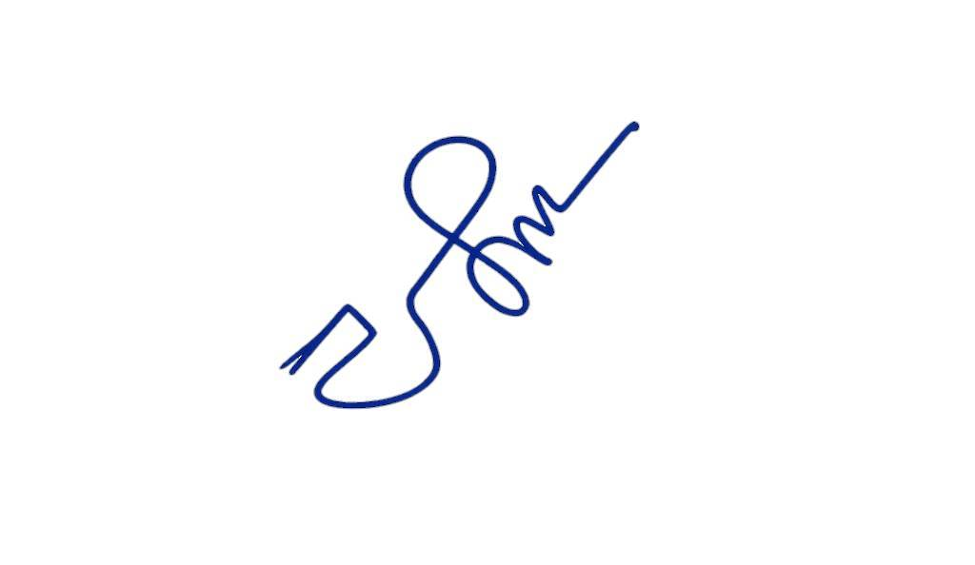
As of April 2. Wednesday 2026

Police Lieutenant Colonel
( Yanatouch chaipocharachote )
Deputy Commander Acting Superintendent
of Lao Luang Provincial Police Station

